Materials and Methods
Data Retrieval
This study utilises two paired-end RNA-Seq datasets from human breast cancer cell lines. Relevant datasets were identified in the NCBI Sequence Read Archive using the keywords “breast cancer”, “RNA-Seq” and “Homo sapiens”. After evaluating multiple publicly available studies, BioProject PRJNA210428 (SRP026537) was selected for its comprehensive profiling of diverse breast cancer models. Within this project we retrieved runs SRR925710 corresponding to Sample ID HCC1954 and SRR925711 corresponding to Sample ID HCC202. Both libraries were prepared from one microgram of total RNA using the Illumina TruSeq Stranded mRNA Kit with poly-A selection and sequenced on the Illumina Genome Analyzer IIx platform in 2015. Key metadata, such as sample origin, sequencing platform, and submitter, were extracted from the NCBI Run Browser and are summarised in Table 1. Raw FASTQ files were downloaded via the Galaxy platform (https://usegalaxy.org) using the Fasterq-dump tool by specifying each SRR accession and selecting paired-end output in gzip-compressed FASTQ format. Integrity and Sanger-encoded Phred+33 quality scores were confirmed prior to downstream processing.
Quality Control and Trimming
Initial quality assessment of each FASTQ file was performed using FastQC version 0.12.1 to examine per-base sequence quality, GC content, sequence duplication levels and the presence of adapter or overrepresented sequences. Reads were then subjected to uniform trimming in Galaxy using Trimmomatic version 0.39, which applied a sliding-window approach of four bases with a minimum average Phred score of 20 and discarded any reads shorter than 36 bases. No adapter-clipping step was employed so as to maintain consistency across both samples. A second FastQC pass confirmed that trimming removed low-quality regions while preserving high median quality scores above thirty and expected GC content around fifty-one percent.
Reference Preparation
The reference sequence for human chromosome seventeen was downloaded from NCBI in GenBank full format (accession NC_000017.11, GRCh38.p14 primary assembly). This file was imported into Geneious Prime version 2024.1 as a multi-sequence list, allowing direct use of integrated gene and exon annotations in downstream alignment and visualisation.
Read Mapping
Trimmed paired-end FASTQ files were imported into Geneious Prime using Illumina quality encoding and an assumed insert size of five hundred bases. Reads were aligned directly to the imported chromosome seventeen reference using the Geneious Mapper with the fastest sensitivity preset, permitting up to two mismatches per seed match of eight bases. Mapping statistics, including total input reads, mapped versus unmapped counts, duplication rates and mean coverage depth, were exported from Geneious for subsequent analysis of BRCA1 transcript abundance and variant detection on chromosome seventeen.
Table 1: General Sequence Properties
BioProject | BioSample | SRA Run | Sample ID | Size (MB) | Region | Isolation Source | Submitter (GEO) | Year | Platform
PRJNA210428 | SAMN02225473 | SRR925710 | HCC1954 | 2900 | N/A | Breast cancer cell line | NCBI (GEO) | 2015 | Illumina Genome Analyzer IIx
PRJNA210428 | SAMN02225573 | SRR925711 | HCC202 | 3400 | N/A | Breast cancer cell line | NCBI (GEO) | 2015 | Illumina Genome Analyzer IIx

Materials and Methods
Title
Mapping of RNA-Seq Reads to Human Chromosome 17 Reference
Example 1
In this study SNP (single nucleotide polymorphism) analysis was undertaken to scrutinize sequence variation within the breast cancer cell line transcriptomes, considering its relevance to oncogenic pathway deregulation. The paired-end RNA-Seq libraries from HCC1954 and HCC202 samples were aligned against the human chromosome 17 GRCh38.p14 reference genome (NC_000017.11) using Geneious Prime v2023.1 mapper set to medium sensitivity. This setting balanced alignment speed and accuracy and allowed detection of both single nucleotide variants and small structural differences. The mapping produced contiguous consensus sequences (contigs) for downstream quantitative and variant analyses.
Read mapping and variant detection
High-quality reads filtered by Trimmomatic (minimum length 36 bp, sliding-window Q20 trimming) were mapped to the chromosome 17 reference in Geneious Prime. Paired reads were retained when both mates passed filtering. Mapping was performed with default mismatch and gap penalties (maximum mismatch=2, palindrome accuracy=30, simple clip accuracy=10) to ensure uniform treatment across both samples.
Results
Title
Mapping of HCC1954 and HCC202 Transcriptome Reads to Human Chromosome 17 Reference
In our study, using Geneious Prime’s medium-sensitivity assembler, 6 413 585 of 63 974 690 HCC1954 reads (10.0 %) were assembled to chromosome 17 to produce a single 83 257 441 bp contig, while 57 561 105 reads (90.0 %) remained unassembled. The consensus exhibited 89.2 % identical sites and 99.2 % pairwise identity; mean coverage was 6.1× (SD 283.1×), with minimum 0× and maximum 103 407× depths and 14.6 % of reference bases (12 176 509 bp) covered. Post-trimming read lengths averaged 89 bp (ungapped 76 bp), mean Phred quality was Q 33.5 (95.3 % ≥ Q20; 86.4 % ≥ Q30), and GC content was 50.7 %.
Similarly, 7 102 813 of 46 569 130 HCC202 reads (15.3 %) were assembled to chromosome 17 generating an 83 359 619 bp contig, leaving 39 466 317 reads (84.7 %) unassembled. The assembly showed 91.4 % identical sites and 99.3 % pairwise identity; mean coverage was 6.4× (SD 192.4×), ranging from 0× to 67 742× with 34.8 % of bases covered (28 963 550 bp). Trimmed reads averaged 83 bp (SD 9.3 bp; min 36 bp; max 76 bp), mean Phred score Q 34.7 (99.4 % ≥ Q20; 94.9 % ≥ Q30), and GC content 52.1 %.

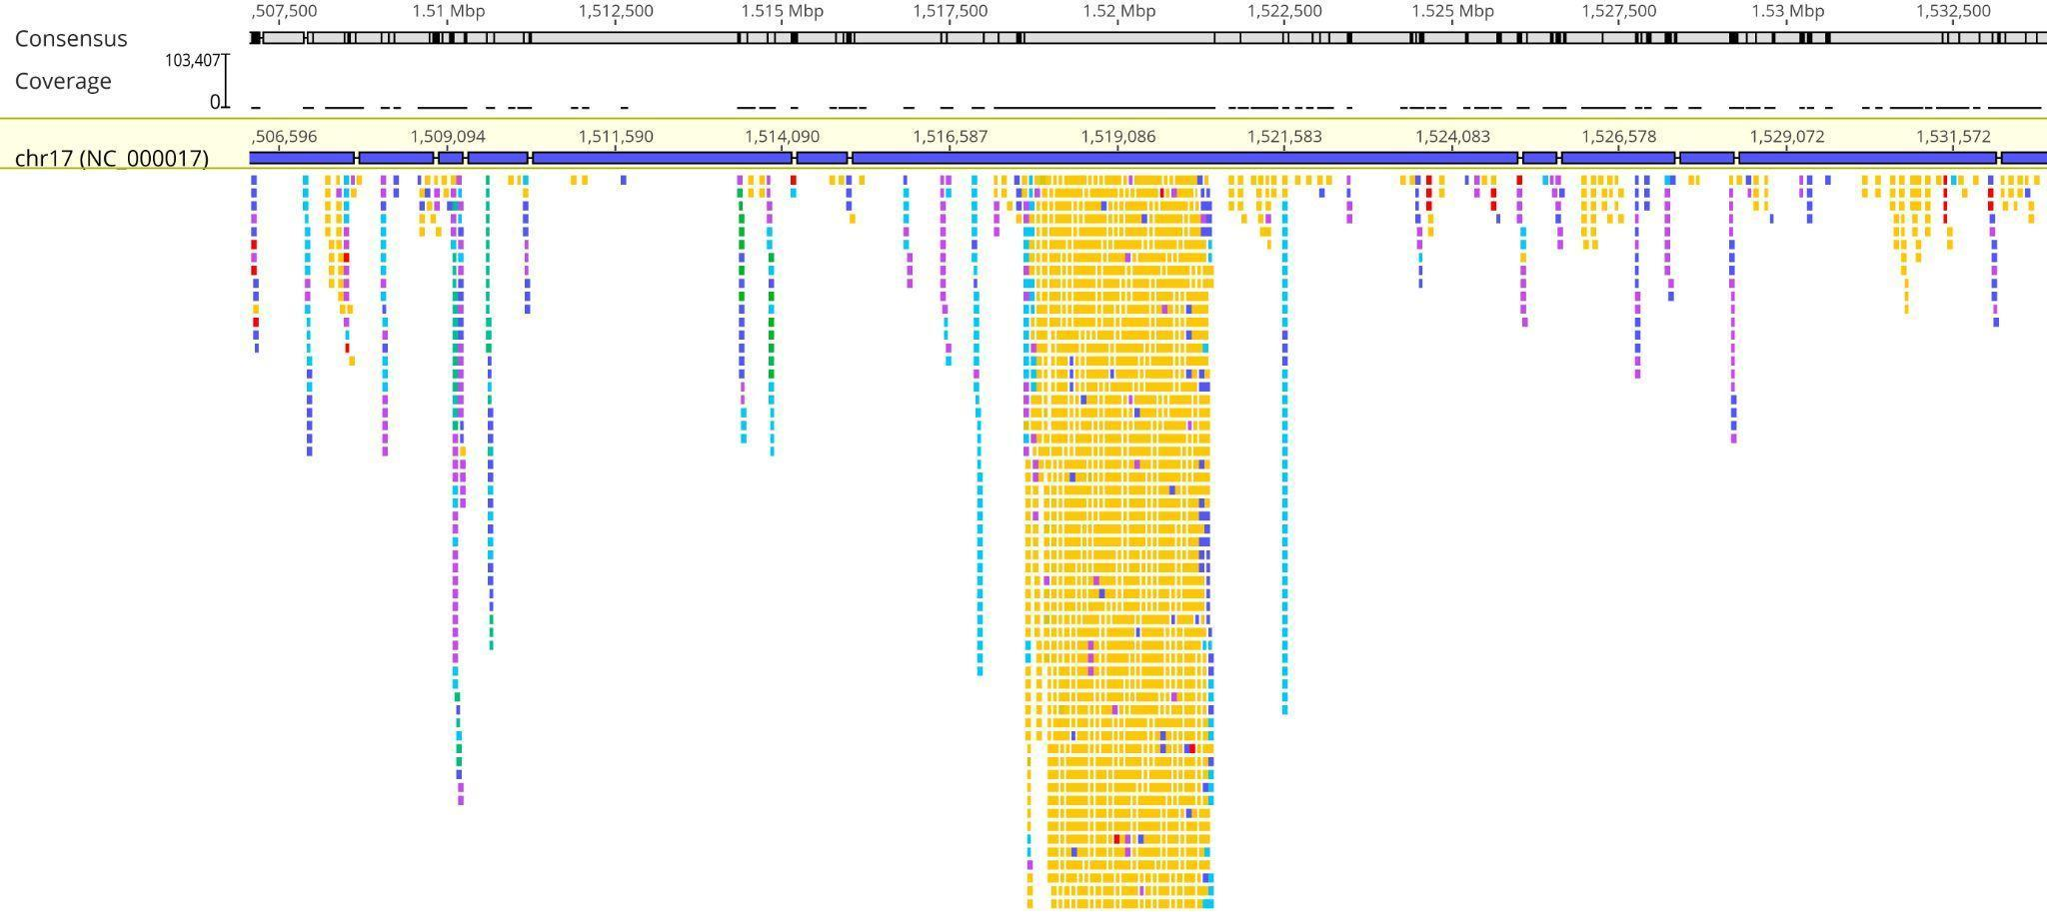

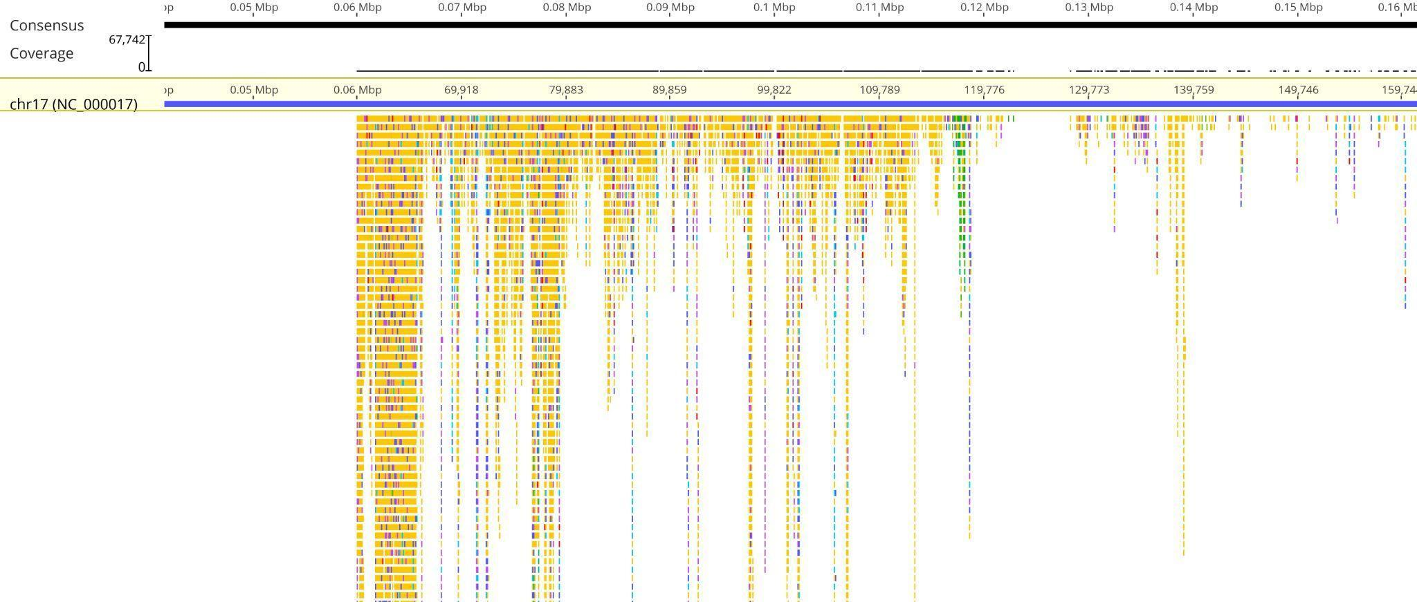

Figure 1 Coverage and read alignment depth for HCC1954 (top) and HCC202 (bottom) RNA-Seq samples mapped to human chromosome 17 (NC_000017.11) in Geneious Prime. The black histogram track shows per-base coverage (maximum depths of 103 407× and 67 742×, respectively), and the coloured boxes beneath represent individual aligned reads, highlighting regions of high expression and transcriptional variation across the chromosome.

Table 2. Statistics of Samples Obtained After Reference Mapping
Metric | SRR925710 (HCC1954) | SRR925711 (HCC202)
Mean read length (bp) | 89 | 83
Total read pairs | 6,413,586 | 7,102,814
Mean coverage (×) | 6.1 | 6.4
Reference covered (%) | 14.6 | 34.8
Coverage SD | 283.1 | 192.4
Mean base quality (Phred) | 33.5 | 34.7
% bases ≥ Q20 | 95.3 | 99.4
% bases ≥ Q30 | 86.4 | 94.9
GC content (%) | 50.7 | 52.1
% ambiguous bases (N) | 0.1 | 0.1

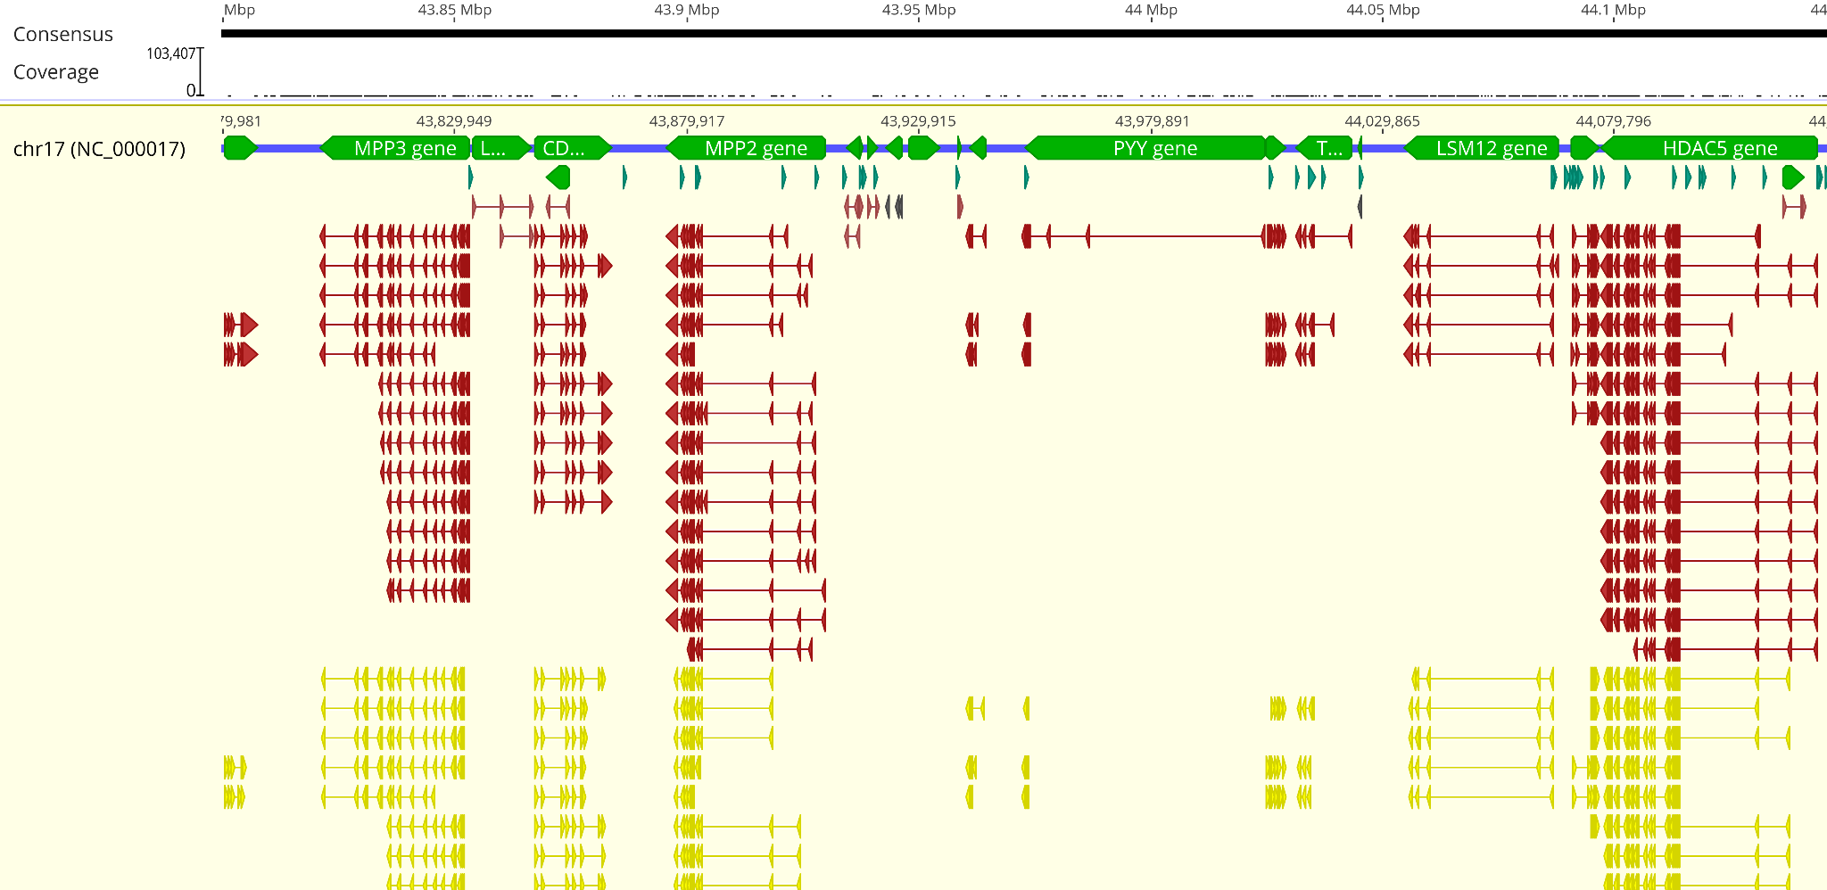
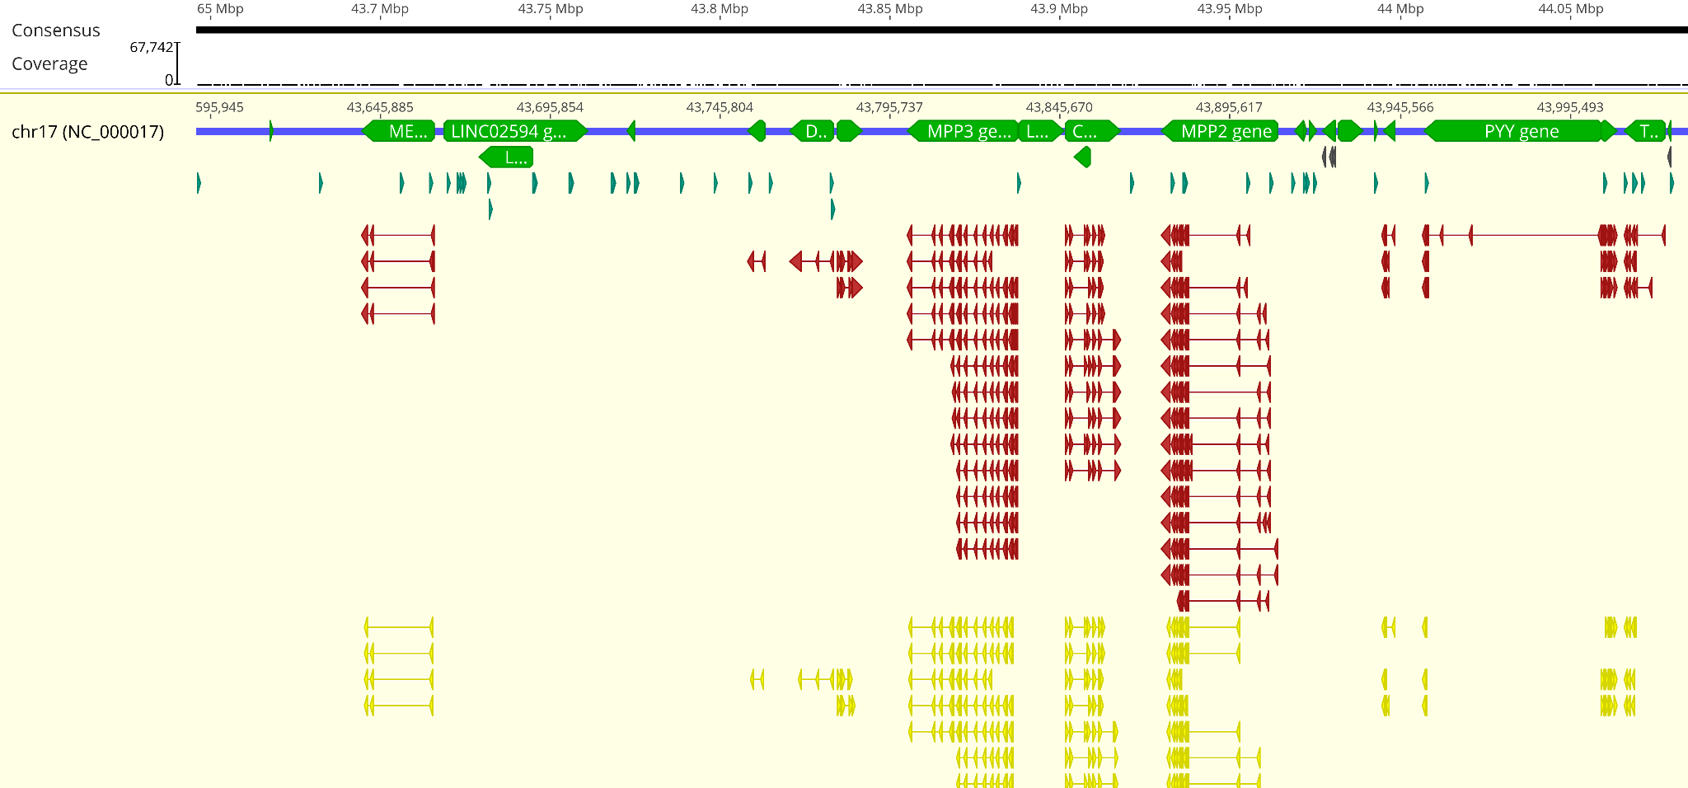
Figure 2. Functional annotation of HCC1954 (SRR925710) and HCC202 (SRR925711) RNA-Seq reads mapped to human chromosome 17. The per-base coverage histograms at the top show read depth across the 83 Mb contigs (NC_000017.11) for HCC1954 with maximum coverage around 103 407× and for HCC202 with maximum coverage around 67 742×. Below each histogram the blue track corresponds to reference coordinates, the green arrows indicate annotated genes and coding sequences derived from GenBank (for example MPP3 and PYY in HCC1954 and MPP2 and PYY in HCC202) and the colored arrows in the lower panels represent transcript-level features such as mRNA, noncoding RNA, regulatory elements, repeat regions, tRNA and mobile elements, illustrating the expressed genomic elements in each breast cancer cell line transcriptome.
S/N | Chromosomal feature | Count
1 | Centromere | 1
2 | Exon | 372
3 | Gene | 2 669
4 | Mature peptide | 328
5 | Misc feature | 25 355
6 | Repeat region | 5
7 | Regulatory | 7 718
8 | Signal peptide | 334
9 | Transit peptide | 32
10 | tRNA | 33
Table 3. Annotation counts extracted from Geneious Prime’s “Annotations and Tracks” panel for SRR925710 and SRR92511 mapped to human chromosome 17 (NC_000017.11)
Materials and Method
Variant Calling, Effect Prediction, and Genomic Distribution Analysis
Breast cancer genomic DNA samples were analyzed using Geneious Prime v9.1.8. Whole Genome Sequencing (WGS) data was aligned to the human reference genome using Geneious Mapper. Variant calling was conducted using the following parameters: a minimum coverage of 1, minimum variant frequency of 0.25, maximum variant P-value of 1 × 10⁻⁵, and minimum strand-bias P-value of 1 × 10⁻⁵ when strand bias exceeded 65%. These settings ensured that only high-confidence variants were retained for downstream analysis. The P-value calculation method was set to Approximate, and strand-bias filtering was applied at a threshold of 65%.
Effect prediction was performed using the “Analyze effect of polymorphisms on translations” function in Geneious, applying the standard genetic code. This enabled the identification of functionally significant changes such as synonymous mutations, missense substitutions, nonsense variants, and potential splice-site disruptions. Codon changes were translated into amino acid substitutions and categorized according to their potential impact on protein structure and function.
Polymorphisms were further annotated by type, including insertions, deletions, tandem repeat variants, and single nucleotide polymorphisms (SNPs). Protein-level consequences were classified into categories such as frame shifts, extensions, and deletions. Reference and observed allele frequencies were also examined to evaluate mutation burden and allelic variation across the sample cohort.
Finally, chromosomal distribution of variants was assessed to identify potential regions of enrichment or biologically relevant clustering. Together, this pipeline enabled the identification of non-synonymous and potentially pathogenic variants in protein-coding genes, contributing to the understanding of mutational mechanisms in breast cancer and supporting biomarker discovery.

